18th Annual
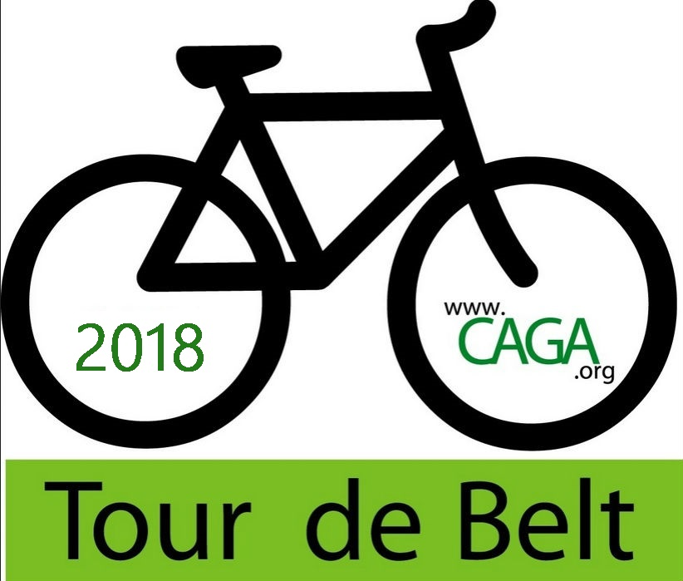
on the Capital Area Greenbelt
Harrisburg Campus of HACC, Central Pennsylvania’s Community College
Sunday June 3, 2018 10:00 AM
The Capital Area Greenbelt Association (CAGA) will be hosting the 18th annual Tour de Belt on the Capital Area Greenbelt. The Ride will follow the Greenbelt - a century-old system of parks and open spaces connected by a 20-mile trail. Starting and ending at HACC-Harrisburg Campus, riders of all ages can participate in a family friendly event that travels through the City of Harrisburg, Paxtang and Penbrook Boroughs, and Susquehanna and Swatara townships. This is not a race. Participants will ride through picturesque natural areas including Wildwood Lake and special places like the beautiful Five Senses Gardens and the Martin Luther King Memorial.
Participants receive lunch and a t-shirt and can enjoy post ride activities. All proceeds raised from the Tour de Belt will be used for the restoration and continued maintenance of this iconic park and trail system. The Capital Area Greenbelt Association is an all-volunteer 501(c)(3) non-profit corporation dedicated to the continued preservation, enhancement and promotion of the Greenbelt. Volunteers provide over 6,000 hours annually maintaining the trail, caring for the surrounding landscape through native planting and invasive species removal, and developing and overseeing trail extension projects. Over $6 million has been raised to improve trail crossings at busy intersections, repair older trail sections and extend the trail to Fort Hunter in 2018.
On average, 800 riders participate annually in the Tour de Belt. An additional 75 volunteers staff the event. We print 4,000 registration brochures that advertise the event and are distributed to bike and coffee shops, libraries, restaurants and key locations throughout the Capital City area and beyond.
Sponsorship Opportunities
The five levels of sponsorship opportunities include: Platinum, Gold, Silver, Champion, and Greenbelt Friends. Opportunities are detailed on the next page. We will work with sponsors to develop tailored packages for volunteer and/or corporate support at varying amounts. Sponsors will appear on the CAGA website. Depending upon the support level, sponsor name/logo will be included on the registration brochure and event t-shirt and provided with a table at HACC on the day of the Tour de Belt. Sponsor commitments must be received by February 3, 2018 to be included in the registration brochure and by May 8, 2018 to be on the t-shirt.
For more information contact:
Dick Norford at phone: 717-460-4684 or email: rnorford@aol.com.

Sponsorship Levels

Platinum (Presenting) $5,000
Sponsor with highest recognition.
- Company Logo & Name prominently displayed in prime position on all promotional material including event brochure, banners, social media, signs and website
- 15 complimentary registrations or youth rider sponsorships
- T-Shirt will feature Company Logo on front
- Choice location of Company table on Day of Tour de Belt at HACC
- Company Name and where possible logo featured in press

Gold (Greenbelt Kids) $2,500
- Sponsorship will provide 10 complimentary registrations for youth riders
- Company Logo & Name prominently featured on event brochure, banners, social media and signs
- Prime table location and priority location on T-shirt
- Company Name and where possible logo featured in press

Silver (Rest Stop Sponsor) $1,500
- Company Logo & Name prominently displayed at rest stop
- 8 complimentary registrations for ride
- Company logo on event brochure, banners, signs, social media and T-shirt
- Table space and company material made available to participants at HACC

Tour de Belt Champion $750
- 6 complimentary registrations for ride
- Company logo on event brochure, banners, signs, social media and T-shirt
- Table space and company material made available to participants at HACC

Greenbelt Friend $500
Businesses/organizations are encouraged to sponsor a “Friends of the Greenbelt Team.” Sponsorship includes 4 complimentary registrations for the ride. Additional riders participate at registration fee rate. Company logo in brochure and T-shirt if received by deadlines.

For more information contact Dick Norford
phone: 717-460-4684 or email: rnorford@aol.com. 11/28/17

